Oracle Database Patching Activity
STEP 1: Check Current Oracle Version and Patch Level
sqlplus / as sysdba
SELECT * FROM v$version;
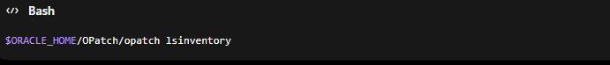
STEP 2: Verify OPatch Version
$ORACLE_HOME/OPatch/opatch version
STEP 3: Take Backup Before Patching
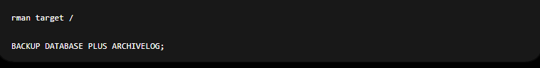

STEP 4: Download and Extract Patch
For Example:
unzip p36912597_190000_Linux-x86-64.zip
/u01/patch/36912597
STEP 5: Check Patch Conflicts

STEP 6: Check System Space
Df -h
STEP 7: Stop Database and Listener
STEP 8: Apply Patch
Move to patch directory:
Apply patch
Verify
STEP 9: Start Listener and Database
STEP 10: Run Data patch

STEP 11: Verify Patch Applied
OS LEBEL
SELECT patch_id, status, action, action_time FROM dba_registry_sqlpatch ORDER BY action_time;
STEP 12: Check Database Status
